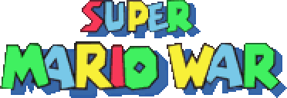
&

(UNOFFICIAL) Level Editor Guide
Written by EleCyon
Original SMWar by 72dpiarmy (See Game Guide for credits)

INTRODUCTION
Having trouble making a battle map for Super Mario War? Look no further than the Level Editor Guide!
This is a detailed guide to using the level editor, bundled with Super Mario War and Super Cat Wars, and saving and uploading your very own map to SMWStuff. Battle maps are a core feature of Super Mario War, as players need a working battle map to play different game modes, stomp around, and interact with several objects.
Click the Level Editor executable in the SMWar folder to start the level editor.
TABLE OF CONTENTS
INTRODUCTION
TABLE OF CONTENTS (YOU ARE HERE)
SECTION 01 – Making a New Map
SECTION 02 – Level Editor Controls
SECTION 03 – Tilesets Mode
SUBSECTION 03.1 – Layers
SUBSECTION 03.2 – Tile Types
SUBSECTION 03.3 – Move Mode
SUBSECTION 03.4 – Animated Tiles
SECTION 04 – Blocks Mode
SECTION 05 – Warp Mode
SECTION 06 – Hazards Mode
SECTION 07 – Moving Platforms
SUBSECTION 07.1 – Platform Types
SUBSECTION 07.2 – Platform Layers
SECTION 08 – No-Spawn Zones
SECTION 09 – Map Items
SECTION 10 – Race Goals & Flag Base Locations
SECTION 11 – Aesthetics
SUBSECTION 11.1 – Backgrounds
SUBSECTION 11.2 – Music (category)
SUBSECTION 11.3 – Eyecandy
SECTION 12 – Saving & Managing Maps
SECTION 13 – Playing your Map (and sharing it!)
SUBSECTION 13.1 – Backgrounds
SUBSECTION 13.2 – Music (category)
THANK YOU FOR READING! (Conclusion)
SECTION 01 – Making a New Map
To start making a new map, press [N]. The screen will darken and you’ll be greeted with this prompt below:
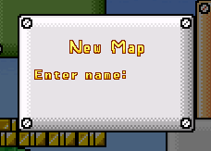
Type in however you want. There is no set character limit, and do not worry if your map name goes off the edges of the box!
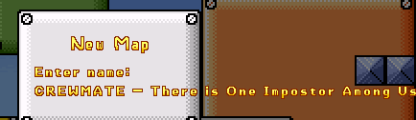
Okay, that was totally not sus, am I right?
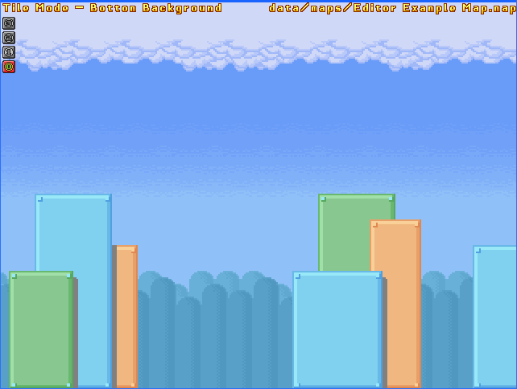
Press Enter to save your new map with its new name. You’ll start with a clean blank slate of a map, but don’t worry, it’s time to build your map with the help of some tilesets, tile types, special blocks, and other bells and whistles.
NOTE: A copy of your map may appear every time you create a new map and save it, this is known as “ZZleveleditor.map”. This serves as an automatic backup in the case of an event such as an editor crash. Note it may be overwritten every time you save a map, so be careful. Deleting this file is completely harmless!
SECTION 02 – Level Editor Controls
Before making your own map, you’ll need to get a hand of the key controls, used by your keyboard. Press F1 to bring up the key guide for editor controls. To enter Full Screen mode (and Windowed mode if you’re in Fullscreen already), press ALT+ENTER. (Screenshot is from SCW, but is otherwise the same as in SMWar)
EDITOR CONTROLS
EDITOR MODE |  | MAP FILE / MENU CONTROLS
T | Tilesets Mode (see Section 03) | N | New Map – type in a new name for the map to create a new one
I | Blocks Mode (see Section 04) | S | Save Map – Save current map (Be careful – there is no confirmation prompt!)
O | Map Item Mode (see Section 10) | Shift + S | Save As – Save map under a new name (type in a new name to save)
W | Warp Mode (see Section 05) | F | Find Map – find maps using the keyword inputted in a new search (see below)
M | Move Mode (see Subsection 03.3) | Shift + F | New Search – Type in a new keyword to search maps with the closest keyword.
L | Tile Type Mode (see Subsection 03.2) | PgUp/PgDown | Cycle through maps in alphabetical order
P | Platform Mode (see Section 07) | Esc | Exit menu / Quit to desktop (may open up a confirm prompt)
X | No Player Spawn Area Mode (see Section 08) | Tile, Warp, & Block modes:  These apply to Tilesets, Warps, Tile Types, Blocks, No-Spawn zones, etc. Mouse functions are further explained in future sections.
Z | No Item Spawn Area Mode (see Section 08) | Left Mouse button | Place tiles/warps/blocks. Can also place multiple by dragging.
H | Hazards Mode (see Section 06) | Right Mouse button | Remove tiles/warps/blocks. Can also place multiple by dragging.
A | Animated Tiles Mode (see Subsection 03.4) | Move Mode  See Subsection 03.3 for more comprehensive information. This is as originally formatted in the Help menu.
K | Block Properties Mode (see Section 04) | Left Mouse button | Select area. Can select multiple blocks by dragging.
J | Race Goals/Flag Bases Mode (see Section 10) (Not shown on Help menu) | Right Mouse button | Deselect area. Can deselect multiple blocks by dragging.
Layer Controls:  See Subsection 03.1 for more comprehensive information. This is as originally formatted in the Help menu. |  | Shift (Hold) | Select multiple areas
V | Hide all special blocks. | Ctrl (Hold) | Freehand selection mode – draw irregular shapes instead of rectangular selections
Y | Cycle between tile layers (0-1 background, 2-3 foreground) | Del | Delete selection
U | Hide inactive/unselected tile layers except for active one | C | Copy selection
END | Optimize layers | Platforms Mode  See Section 07 for more comprehensive information. This is as originally formatted in the Help menu.
MISCELLANEOUS |  | P | Set platform path (see Section 07)
B | Backgrounds menu (see Subsection 11.1) | + or - | Change platform speed (outside of Platform Path mode)
G | Cycle through backgrounds in alphabetical order (on map) | Del | Delete platform (Warning: There is no confirmation prompt, so be careful!)
R | Change music category (see Subsection 11.2) | REMEMBER: You can open up the Help menu by pressing F1.  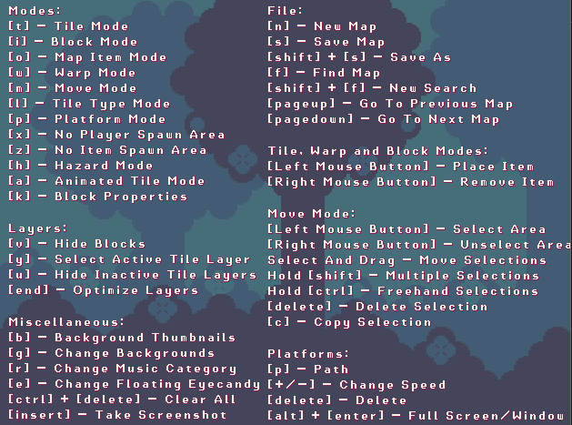
E | Eyecandy menu (see Subsection 11.3)
CTRL + DEL | Clear All [ Warning: All data on the map will be lost! ]
INS | Take screenshot (saved in “maps/screenshots”)
ALT + ENTER | Switch between Full Screen and Windowed modes

SECTION 03 – Tileset Mode
Now, let’s get to the basics. It’s about time you make a layout for your map, right? This is when the Tilesets Mode comes in. Press [T] to open up the tilesets menu.
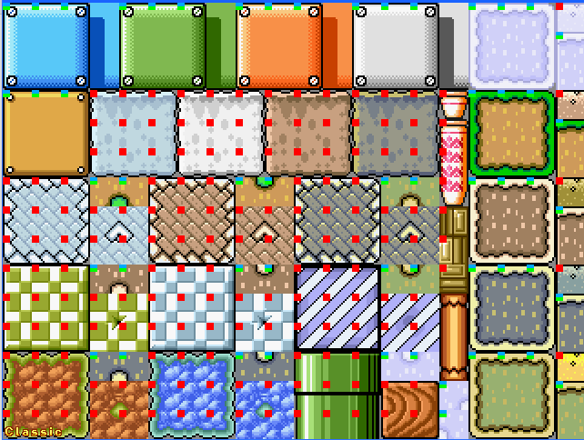
You’ll be greeted by lots of placeable tiles! You can also add your own tilesets to the game, but that’ll be explained later. For now, let’s build!
CONTROLS FOR TILE MODE
Left Mouse Button | Select tile (Drag to select multiple). On the map, click to place tiles.
Middle Mouse Button (SMWar 2.0 & SCW only) | Change tile type (cycle backwards)
Right Mouse Button | Change tile type (cycle forwards). On map, click to delete tiles.
Numbered keys (1-9) / PgUp/PgDown | Change tileset sheets. PgUp & PgDown selects more!
Arrow keys | Navigate tileset sheet
Any other key | Exit

If there are multiple tileset sheets in the game, you can use the PgUp/PgDown keys to scroll to other tileset sheets. Here are some of the other tileset sheets you may find in default SMWar:
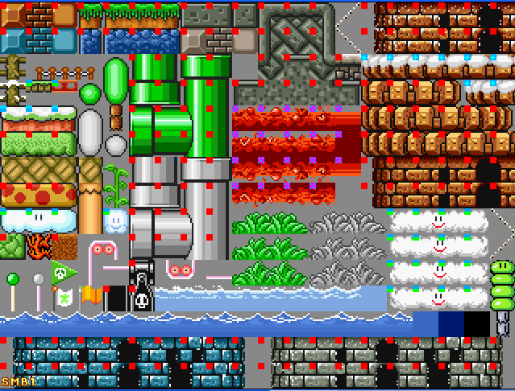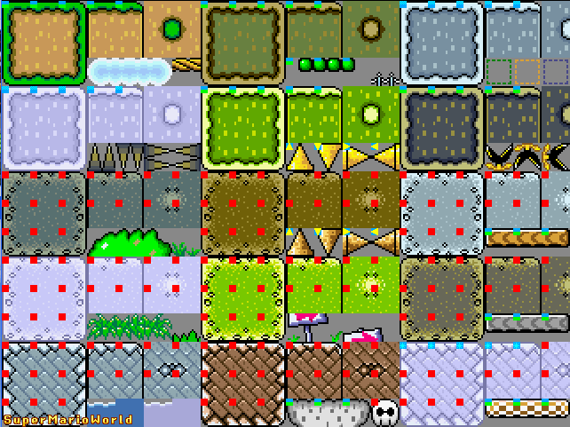
Each tile has a pre-defined tile type that is automatically applied to the tile when it is placed on the map. Right click to change the tile type used, and hold to apply the same tile type to other tiles by dragging.
Left-click to add tiles to the map, and build your own layout!
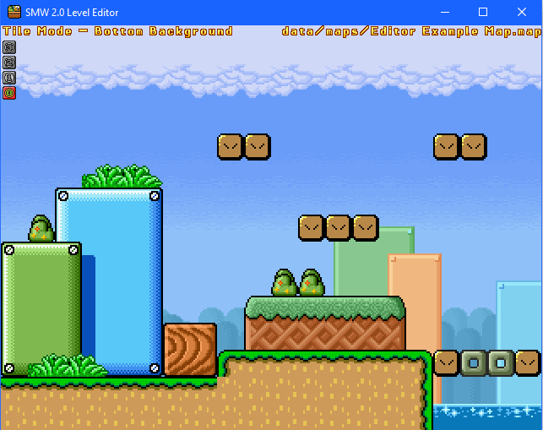
Here’s a set of tiles placed with the Tile Mode. There you go, you made a basic layout for a map!
SUBSECTION 03.1 – Layers
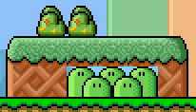
I HATE THE GOSH DARN CUT-OFF MAN!!
There are some occasions where some deco you try to place may cause cutoffs in other tiles, making it a pain to place background objects on existing tiles. This is because placing tiles on the same layer of tiles can cause some tiles to be replaced.
This is when the Layers feature comes into play.
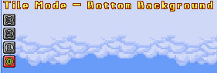
If you see these set of numbers in the top left corner of the screen, these are the four layers of the map. 0 is Bottom Background, and 1 is Top Background, which draws over the Bottom Background layer. Foreground layers are 2 and 3, and in addition to drawing over the background layers, they also draw over various assets in the game like players, enemies, items, and map objects.
Press [Y] to change the layer.
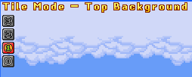
Now, you can place tiles like decoration over other tiles, and it looks much neater now without cutoff!
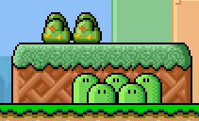
Additionally, you can press [U] to view the map but with the tiles on the selected layer displayed only.
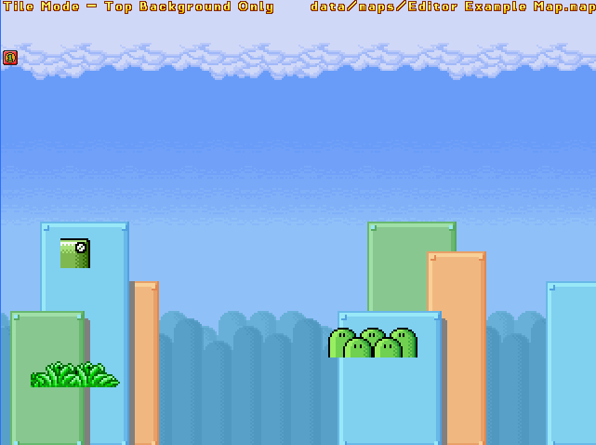
This may look ugly, but it helps players figure out what tiles are on a specific layer, etc. Press [U] again to disable it.
SUBSECTION 03.2 – Tile Types

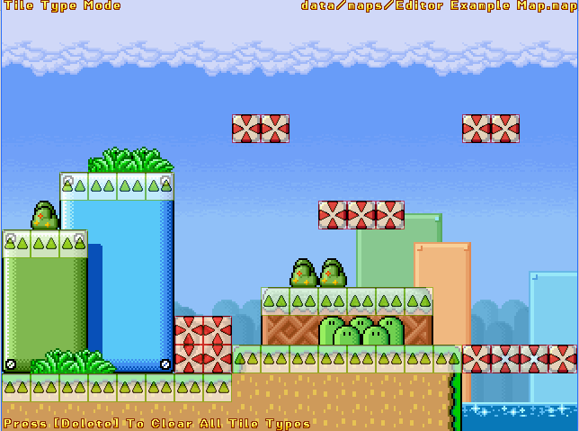
Collision is very important, as without them, players may accidentally fall off platforms in the wrong places or bump into hazards that don’t look exactly like they should.
Press L to open up the Tile Types menu, which displays various tile types in a row. The following section lists the various tile types and how to use them (left-to-right):
(Top: Super Mario War | Bottom: Super Cat Wars)
- SOLID – Solid block collision that affects all sides of the block. Can be used like walls, floors, or ceilings. They also prevent players, mode objects, and map items from spawning inside of them.
- SEMISOLID – Tile type that players can walk on, but can be jumped through from the sides and bottom. Players can also press DOWN to drop through semisolid tiles.
- ICE – Tile type similar to Solid, but the surface is very slippery and causes players to skid for long distances.
- DANGER – A tile type that kills players upon touch, unless if invincibility from certain conditions is obtained. There are tiles for death on all sides (skull and crossbones), and for spikes (up, down, left, right).
- SLIPPERY SEMISOLID – A tile type similar to Semisolid but is very slippery, just like Ice.
- SLIPPERY SPIKES – Only available as down, right, and left variants (as an up-facing spike already kills players on surface contact). These act similarly to the spike properties of Danger, but are also very slippery when players walk on its surface, just like Ice.
- DEADLY – A tile type similar to Danger, but it kills players regardless of invincibility, destroys items, enemies, and mode objects (with some respawning in a different location), and subtracts points from the player. Comes in tiles for death on all sides and for spikes.
- MILD DEADLY – A tile type similar to Deadly, but it does not subtract points from the player. This death tile does not have any spike tiles. Any items, including carryable ones, can pass through them.
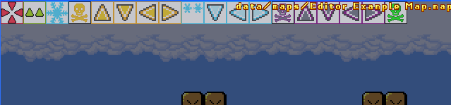
Click on a tile type on the Tile Types menu to select it. Use the left/right mouse buttons to place/delete the tile type.
On the map preview, you can press DEL (Delete) to clear all Tile Types from the map. USE WITH CARE – ALL TILE TYPES WILL BE DELETED AND IT WILL TAKE A WHILE FOR YOU TO SET THEM UP AGAIN IF YOU DELETE ALL OF THEM BY ACCIDENT.
SUBSECTION 03.3 – Move Mode
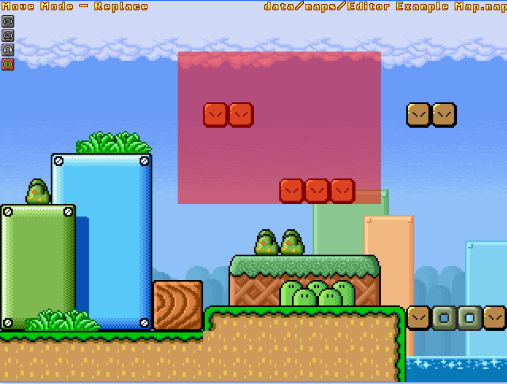
There is an option to select tiles on the map and move them around. Press M to enable Move Mode, which works like the typical click-and-drag tile move in editors like Super Mario Maker 2.
CONTROLS FOR MOVE MODE
Left Mouse Button | Click and hold to make a selection.
Right Mouse Button | Click and hold to delete part of selection.
Hold SHIFT | Make multiple selections
Hold CTRL | Freehand selection – can draw a custom area instead of being locked to a quadrilateral selection.
C | Copy selection – copies selected area and can be placed by using the mouse. Left-click to paste, right-click to delete copied blocks.
M | Toggle submode – Merge/Replace.  - Merge will cause all layers to be merged without replacing existing tiles.  - Replace will overwrite tiles regardless if they are on a different layer or not.

Copying Tiles
By pressing C, when selecting tiles, you can copy a portion of the map that you selected and paste it somewhere. Here’s how to use it, in images:
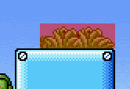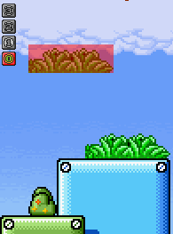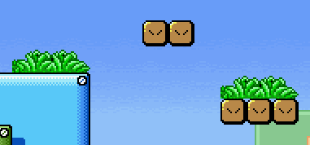
Note that the Move feature also selects all tiles from EVERY LAYER. Pressing U makes it easier to deal with such, as you can select tiles on a single layer only instead of selecting tiles from multiple layers.

Move Submodes & Working with Layer Hiding
This sub-subsection should make it clearer to understand how Move submodes work. Press M in Move Mode to toggle between Merge and Replace submodes.
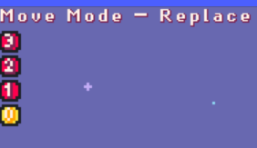
On the top left of the editor, you can see which submode you are currently on. By pressing M, the Replace text displayed on the top left would be replaced with Merge, signifying the submode change to the Move (Merge) submode.
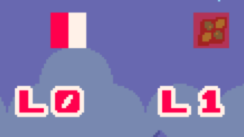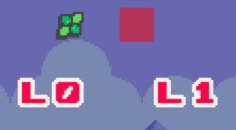
This is Replace submode. Regardless of layer, the tile is still overwritten with the moved tile.
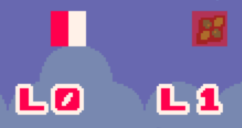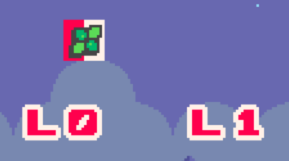
This is Merge submode. A tile on a higher layer can be merged with its lower layer tile by dragging the tile over it, and vice versa.
Additionally, layers can be separated by once again pressing U to hide inactive tile layers. This mode works with conjunction wth Move Mode as with most modes used in the editor, and it can be used to clean up any tile layers merged on top of one another by accident. See the following images below: 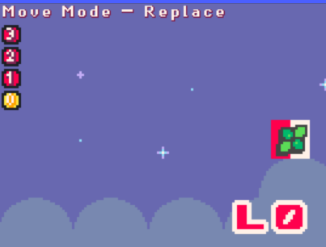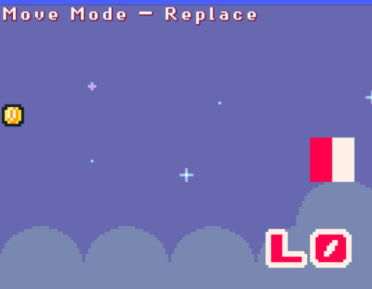 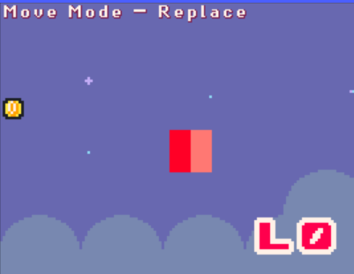 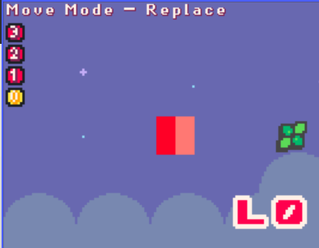
Do note that attempting to move tiles without Hide Inactive Layers (U) enabled will cause all tiles on every layer to be moved. This can get very messy if used improperly, so be careful!
SUBSECTION 03.4 – Animated Tiles
Starting with SMWar 1.8 Beta 1 up to SMWar 2.0/SCW, the game now has the ability to add animated tiles to the level. These tiles have four frames and are animated in-game (they are not animated in the level editor, for reference)
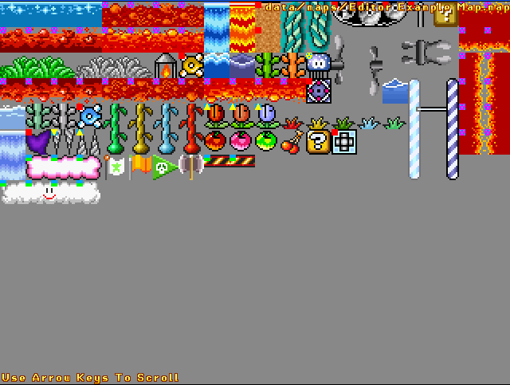
As usual, animated tiles are handled in the same way as tilesets and have the same hotkeys used for placing them, but note that the game can only have one animated tileset and nothing else.
SECTION 04 – Blocks Mode
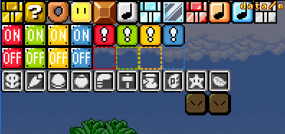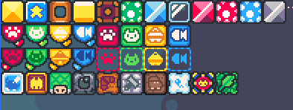
Your map needs special blocks to spice up the fun. Blocks Mode causes the player to select and place special blocks ONLY. Special Blocks refer to the various blocks that the players can interact with, like ? Blocks/Star Blocks and the Switch Blocks.
While the various blocks and their functions are listed in the SCW SMWar Game Guide, they are listed here for convenience. Listed in order of display on Blocks Mode:
- Brick/Yellow Stone Block – Breaks when hit from below or from the side.
- ? Block/Star Block – Produces a random item when hit.*
- Donut Block/Falling Log – Falls after a short amount of time.
- Rotating Block – Rotates and makes it temporarily passable when hit.**
- Bounce Block – Hits players from the top when hit from below.**
- White Note/Green Mushroom Block – Makes players bounce when hit from any side. Hold UP for a big jump.**
- Throwable Blue Block – Toss this at other players or enemies to defeat them.
- View Block – Shows the item stored inside the block before being hit.*
- Throwable Red Block – Same as the blue variant but can bounce off walls and hit multiple players.
- Orange Note/Red Mushroom Block – Similar to the white note/green mushroom block but produces an even higher jump when pressing UP.**
- Blue Note/Mushroom Block – Players can bounce off it but are unable to perform a high jump either.**
- Throwable Gray Block – Same as the blue variant but can hit multiple players.
- Switch Blocks – Toggles blocks of the same color.
- Dotted-Line Blocks – Can be toggled by Switch Blocks, solid ones cannot be passed through while dotted-line versions are passable.
- Weapon Blocks – Must be broken with the corresponding weapon on the icon itself.
*Item probabilities and hidden block property can be set by pressing K when hovering your cursor over said block
**Only hidden block property can be set by pressing K
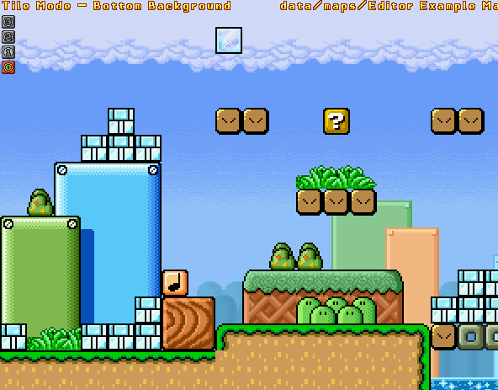
Additionally, if you press K while hovering on certain types of blocks, additional settings for that specific block you hovered over with the mouse will be shown.
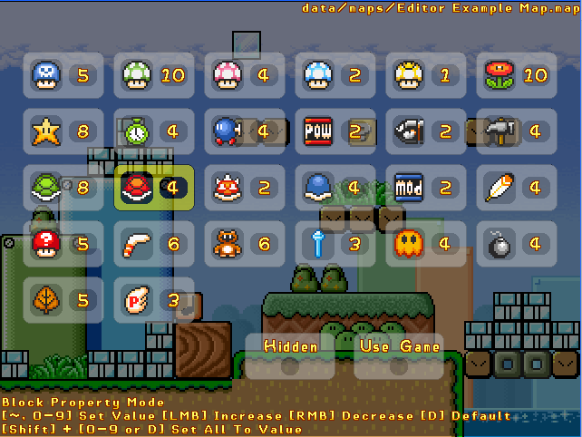
This is Block Property Mode when selecting View Blocks or ?/Star Blocks. In this menu, you can set the probabilities of the items that appear, as well as a special property that marks the block as hidden until hit.
CONTROLS FOR BLOCK PROPERTY MODE
Left Mouse Button | Increase item value (? Blocks/View Blocks)
Right Mouse Button | Decreases item value (? Blocks/View Blocks)
Numbered keys (0-9) & ~ | Set item value for selected item. Press ~ for 0, 0 for 10. (? Blocks/View Blocks)
D | Default value for selected item (? Blocks/View Blocks)
Shift + Numbered keys or D | Set all item values for all items to a specific number, or set them all to default (? Blocks/View Blocks)

Hidden is a toggleable option that hides the block on the map until it is hit. It is the only option shown if Block Properties are shown for other blocks than a ? Block/View Block. Use Game sets the item probabilities to be adjusted according to the Item Selection settings in-game.
You can also hide blocks in a similar fashion to hiding layers. Press V to toggle viewing of special blocks on the map.
SECTION 05 – Warp Mode
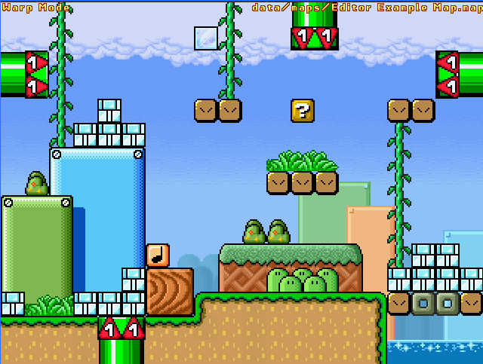
Warps refer to special map tiles that can be entered by the player. Press W to bring up Warp Mode and place warps around the map.
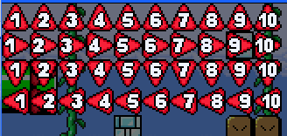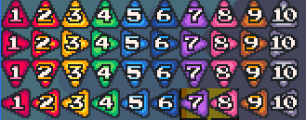
There are four different directions for a warp, as well as ten IDs for each warp (1-10). You can place as many warps as you want, remember that. Up arrows allow the player to enter from the top by pressing DOWN. Right arrows are placed on walls and can be entered from the left by pressing LEFT. Down arrows are placed on ceilings and can be entered from the bottom by pressing UP. Left arrows are placed on walls, too, and can be entered by pressing RIGHT.
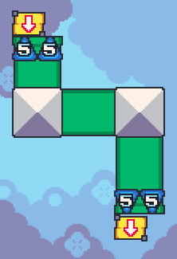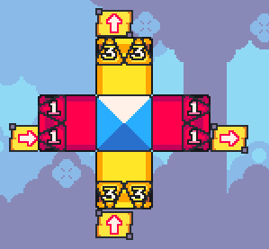
Warps with the same ID link to each other. Two warps linked to one another allow the player to enter one warp and come out of the other.
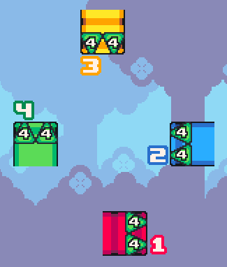
Multiple warps on the same ID create random exits for the player. Player enters Warp 1, and comes out of Warp 3. Next time when the player enters the same Warp 1, they come out of Warp 4, and so on.
If a Warp ID has only one warp, the player entering it will come out of the same warp. This trick can be used to create “sneak zones” that allow the players to get temporarily invincibility and hide from attacks.
SECTION 06 – Hazards Mode
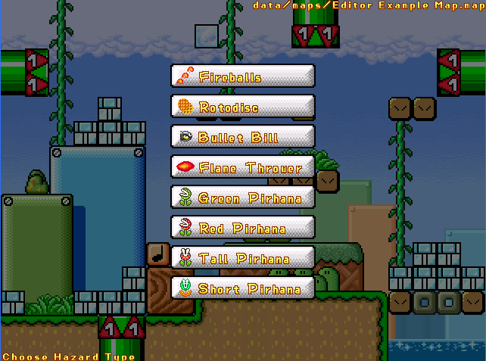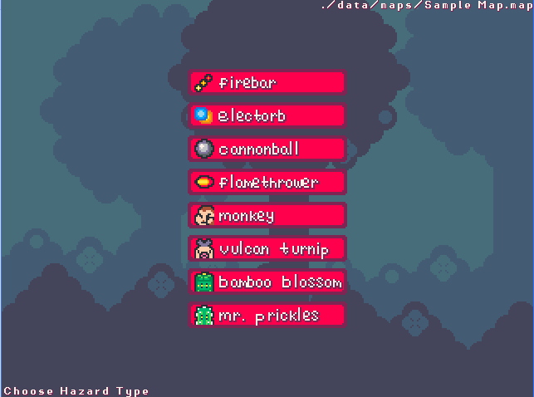
Hazard Mode lets the player choose, set, and place hazards on the map. Press H to enable Hazard Mode.
Keep in mind that most, if not all hazards have both PROPERTIES (P) and LOCATION (L) modes. Properties sets the special properties of a selected hazard, while Location allows the player to set the location by clicking and dragging the mouse. A map can have up to 32 hazards.
There are eight types of hazards that are used on the map:
FIREBALLS/FIREBAR
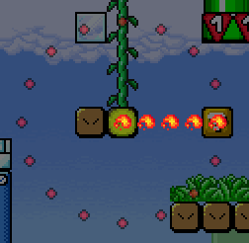
This is a rotating bar of fire that goes around in a circular path.
Properties (P):
VELOCITY (shown below): Press (- or +) to set the speed of the firebar. The firebar will spin counter-clockwise if the cursor is on the red parts, and clockwise if on the green parts. The middle (gray) will cause the firebar to be stationary.
ANGLE & RADIUS (shown below): Use the left mouse button to adjust the radius and the starting angle of the firebar. The larger the radius, the more fireballs on the firebar. Hold SHIFT to snap to angle.
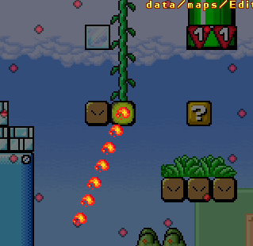
ROTO-DISC/ELECTORB
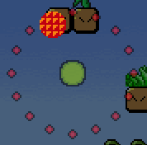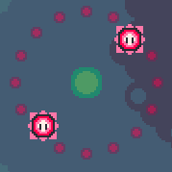
This is a rotating nuclear waffle glowing disc (or electric orb enemy in SCW) that goes around a set circular path. It cannot be destroyed by projectiles but players can touch it safely with invinncibility.
Properties (P):
VELOCITY (shown below): Press (- or +) to set the speed & direction of the roto-disc/Electorb. It will spin counter-clockwise if the cursor is on the red parts, and clockwise if on the green parts. The middle (gray) will cause the enemy to be stationary.
ANGLE & RADIUS (shown below): Use the left mouse button to adjust the radius and the starting angle of the firebar. The larger the radius, the more fireballs on the firebar. Hold SHIFT to snap to angle.
NUMBER (1-9) (shown below): Press the numbered keys 1-9 to set the number of Roto-Discs/Electorbs on the set path.
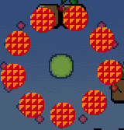
You monster, why would you do this!?
BULLET BILL/CANNONBALL
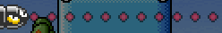
Bullet Bills/Cannonballs are hazards that travel in a straight line and launch at a specific frequency and speed. They can be stomped on to dispatch them. Setting the location of its launch will set the tile it comes out from to be on the adjacent tile.
PROPERTIES (P):
Direction & Velocity (shown below): Press (- or +) to set the launch speed and direction. The path dots may space out depending on speed. To instantly set direction while preserving velocity, press D.
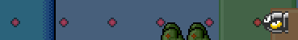
Frequency (shown below): The frequency of Bullet Bills/Cannonballs being launched can be set with ( [ / ] ), or ( < / > ). The more the cursor is to the left, the more Bullet Bills/Cannonballs are launched often.
FLAMETHROWER:
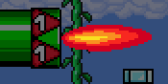
Flamethrowers jet out dangerous three-tile long/tall flames that can hit players.
PROPERTIES (P):
Frequency (shown below): The frequency of Flamethrowers being activated can be set with ( [ / ] ), or ( < / > ). The more the cursor is to the left, the more frequent the Flamethrower activates.
Direction: Press D to set the direction of the Flamethrower. They can be aimed upwards, downwards, or sideways.
FIRE PIRANHA PLANT (Green Piranha/Red Piranha) / Monkey & Fire plant minion
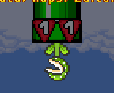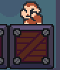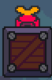
Fire Piranha Plants/Monkeys/fire plant minions may occasionally come out of pipes/tiles, aim at the player they first see, then shoot a fireball towards them. The fireballs and these enemies can hurt the player when touched. They act the same regardless of color or appearance (since there are two types of this enemy), and can be defeated with projectiles or invincibility.
PROPERTIES (P):
Frequency (shown below): The frequency of this enemy coming out can be set with ( [ / ] ), or ( < / > ). The more the cursor is to the left, the more often said enemy comes out.
Direction: Press D to set the direction of the enemy. They can be aimed upwards, downwards, or sideways.
PIRANHA PLANT (Tall/Short) / Bamboo Blossom & Mr. Prickles
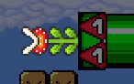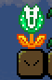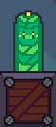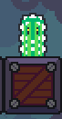
There are two types of Piranha Plant. One is the Tall Piranha Plant (Bamboo Blossom in SCW) which is two blocks long, and the other is the Short Piranha Plant (Mr. Prickles in SCW) which is one-and-a-half blocks long.
Piranha Plants’ attack strategy is to come out of certain tiles (notably Warp Pipes) to attack the player, much like their original appearance in the Super Mario series. They can be defeated with projectiles or invincibility.
PROPERTIES (P):
Frequency (shown below): The frequency of this enemy coming out can be set with ( [ / ] ), or ( < / > ). The more the cursor is to the left, the more often said enemy comes out.
Direction: Press D to set the direction of the enemy. They can be aimed upwards, downwards, or sideways.
SECTION 07 – Moving Platforms
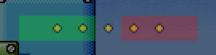
Moving platforms allow for a dynamic map setting, where moving platforms can be used to transport players to other parts of the map, create an auto-scrolling section, or just simply be used as a hazard in many ways (like being a crusher hazard).
Press [P] to open up Platforms Mode. The further subsections will explain different types of platform paths, as well as layer rendering priorities (for advanced users).
Press [C] to check platform paths, if there are any existing platforms. This will display the platforms in action.
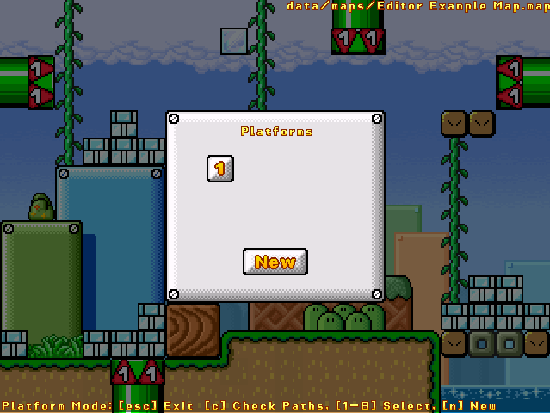
CONTROLS FOR PLATFORMS MODE
PLATFORM MENU
Left Mouse Button | Click New to make a new platform. Click a platform ID to modify an existing platform. Hover your cursor over a platform ID to preview the platform’s tiles.
C | Check paths, this will display how the moving platforms look on the map.
Numbered keys (1-8) | Hotkey for selecting platform IDs.
N | Hotkey for making new platforms.
EDITING PLATFORMS
T | Bring up tilesets. See Tileset Mode section for controls.
A | Bring up Animated Tiles
L | Bring up Tile Types
Delete (del) | Delete platform (Use with caution!)
P | Modify platform path
Plus key/minus key [ + / - ] | Set platform velocity. In Ellipse mode, it can also be used to set the direction the platform goes in the elliptical path.
Y | Set platform draw layer
PLATFORM PATHS
Left Mouse Button  (Hold SHIFT to snap to position/angle) | LINE SEGMENT  - Set starting point of path.  CONTINUOUS  - Set path location.  ELLIPSE  - On its own: set center location.  - LMB+Z: Set Y radius (Vertical)  - LMB+X: Set X radius (Horizontal)  - LMB+C: Set circular radius
Right Mouse Button  (Hold SHIFT to snap) | LINE SEGMENT  - Set end point of path.  CONTINUOUS  - Set path angle.  ELLIPSE  - Set starting point for path.
T | Change the path type.

The maximum number of platforms the player can place in legacy Super Mario War 1.8 is eight, but due to the nature of this being an editor limitation instead of a map limitation, this has been raised to 32 in mmatyas’ SMWar 2.0 builds and Super Cat Wars.
Fun fact: The limitation increase was made possible with original research from me and mmatyas. It’s possible for the game’s maps to support up to about 65000 moving platforms (technically), but there are only 32 numbered button GFX made for the editor, which leads to the number of moving platforms being 32.
Maps with more than 8 moving platforms have been tested in legacy SMWar 1.8 and even older builds of mmatyas’ Super Mario War, and they have been confirmed to work without any crashes.
SUBSECTION 07.1 – Platform Types
Okay, so this section is going to be very complex to explain, so read carefully. There are three platform types that can be used as of 1.8 Beta 2/SMWar 2.0:
LINE SEGMENT
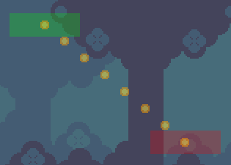
This is the most basic type of platform path. The platform travels back and forth between a straight line which has a start (green) and end point (red). The size of the green/red zones depends on how many tiles does your platform have, so use it as a guide when making platforms like elevators.
The Left Mouse Button can be used to set the start point, and the Right Mouse Button can be used to set the end point. Press SHIFT to snap.
The speed can be set by pressing [ - / + ]. The more the cursor is to the left, the slower the platform will move. The more the cursor is to the right, the faster the platform will move.
CONTINUOUS
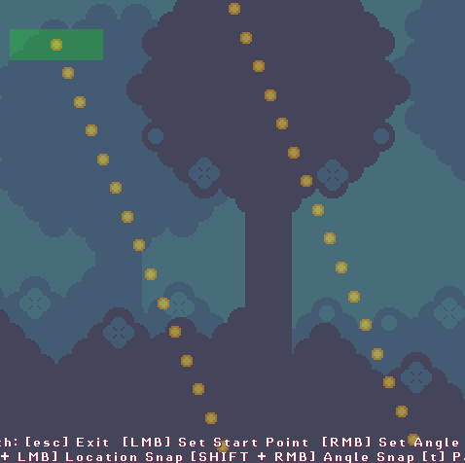
Continuous refers to a path that has no start or end point. It travels in a straight line, wrapping itself around the screen horizontally or vertically. This can be used to make “auto-scroll” battle maps.
Technically speaking, when a platform wraps horizontally around the map, it comes out from either side almost instantly. However, for platforms that can go up or down a specific direction, it will take a while for them to wrap vertically around the map, making vertical-scroll maps not ideal to make in the level editor as it leads to cutoffs.
Press LMB to set location. Press RMB to set angle. Hold SHIFT to snap.
The speed can be set by pressing [ - / + ]. The more the cursor is to the left, the slower the platform will move. The more the cursor is to the right, the faster the platform will move.
ELLIPSE
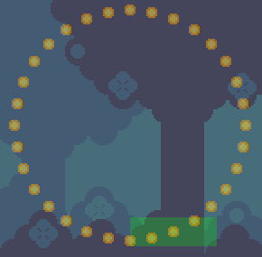
An ellipse path refers to a circular path a platform travels in. In a similar fashion to Continuous, there are no start and end points for the path. The X radius (horizontal shape) of the path can be adjusted by pressing LMB+X, which will look like this:
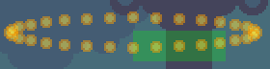
The Y radius (vertical shape) of the path can also be adjusted by pressing LMB+Z, which will make it look like this as well:
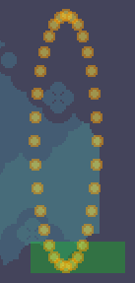
Lastly, the radius size of the elliptical path can be set by pressing LMB+C. This will revert the path back to a circle shape, and its size can be adjusted this way:
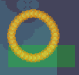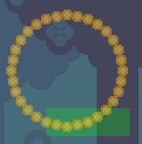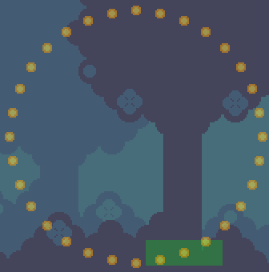
Speaking about the right mouse button, it can be used to adjust the starting position of the platform itself. SHIFT key can also be used here to snap the starting position.
Platform speed is handled differently in Ellipse mode. The red parts indicate the platform is going to move counter-clockwise (left), and the green parts indicate the platform is going to move clockwise (right). The closer the cursor is to the end of the red/green parts, the faster the platform will move. As usual, the speed can be changed with [ - / + ].
SUBSECTION 07.2 – Platform Layers
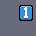
Platforms have FIVE layers that can be switched to by pressing Y to choose a draw layer. Notably, platforms take higher priority in map rendering, and draw over all static tiles and even other platforms.
Layer IDs 1-2 are background layers, Layer IDs 3-5 are foreground layers. Platforms that are on a higher layer ID than other platforms take the higher priority in rendering over other platforms & tiles. Notably, the highest Layer ID (5) may also draw over the timer HUD seen in modes like Star and Time Limit.
Technically speaking, a platform on the same draw layer as the other platform may take higher render priority if its platform ID (1-8 or 1-32) is higher than the other. For example, Platform ID 1 (with draw layer 1) and Platform ID 2 (with draw layer 1) are two separate platforms, but Platform ID 2 draws over Platform ID 1 due to its higher priority.
SECTION 08 – NO-SPAWN ZONES
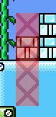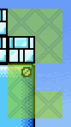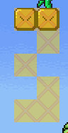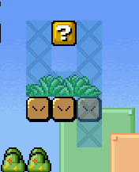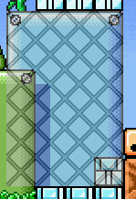
There is an option to prevent certain teams or players from spawning in specific areas. This is No Player Spawn mode. Press X to enter this mode.
CONTROLS FOR NO-PLAYER SPAWN MODE
Left Mouse Button | Click to place no-spawn zones.
Right Mouse Button | Click to remove no-spawn zones.
X | Use global no-spawn zones – prevents ALL players from spawning within these zones.
Numbered keys (1-4) | Use team no-spawn zones – prevents certain teams from spawning within these zones. Note that each numbered zone is on a different layer.  - Red zones prevent spawning of Player 1.  - Green zones prevent spawning of Player 2.  - Yellow zones prevent spawning of Player 3.  - Blue zones prevent spawning of Player 4.
A | Fill entire map with currently-selected zone type.
N | Clear all no-spawn zones for a selected type.
I | Invert area of no-spawn zone. Air will be filled with no-spawn zones and vice versa.

No Player Spawn Zones are useful for creating Capture the Flag maps and team-based maps, where teams can spawn in areas specific to them. They are also used in conjunction with No Item Spawn Zones, which are explained below:
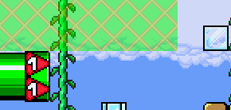
These are green areas with a red X over them that prevent items from spawning in these zones, specifically mode objects like eggs/bells, Domination bases, and other things. This is useful if you want to keep objects from spawning inside unreachable spots.
SECTION 09 – Map Items
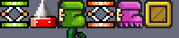
Press [O] to bring up Map Items mode, whch allows you to place special map items the player can use. These map items are already explained in the Game Guide, but are explained here for convenience:
- Green Trampoline/Mushroom: Acts like a holdable Note/Mushroom Block. Hold UP when bouncing off a trampoline to perform a high jump.
- Carryable Spike/Jellow: A holdable spike that can hurt players when jumped on.
- Goomba’s Shoe/Rollerskates: A rideable item that players can use to perform a super stomp. Press DOWN to perform a super stomp, and mash LEFT+RIGHT to get off the shoe.
- Red Trampoline/Mushroom: Acts like the green variant but players can perform an even higher jump when they hold UP.
- Crate/Box: Can be held and tossed to reveal items. They reveal coins instead if the map in question is played on Boxes Minigame Mode.
Controls are simple, just press LMB to select an item and place it on the map. Press RMB to remove map items in this mode.
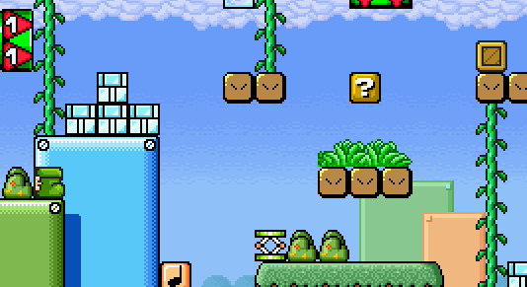
When placed on the map, map items remain for the rest of the game, until they are destroyed by something else. In fact, map items disappear forever from the current match if they fall into Deadly/Mild Deadly tile types or get crushed between a solid tile and a moving platform (or two moving platforms).

SECTION 10 – Race Goals and Flag Base Locations
There is an additional menu to access modification of locations of the race goals and flag bases, which (in 1.8 Beta 2 only) is not documented on the list of controls when pressing F1, for some reason. Press [J] to bring up the menu to set race goals and flag bases.
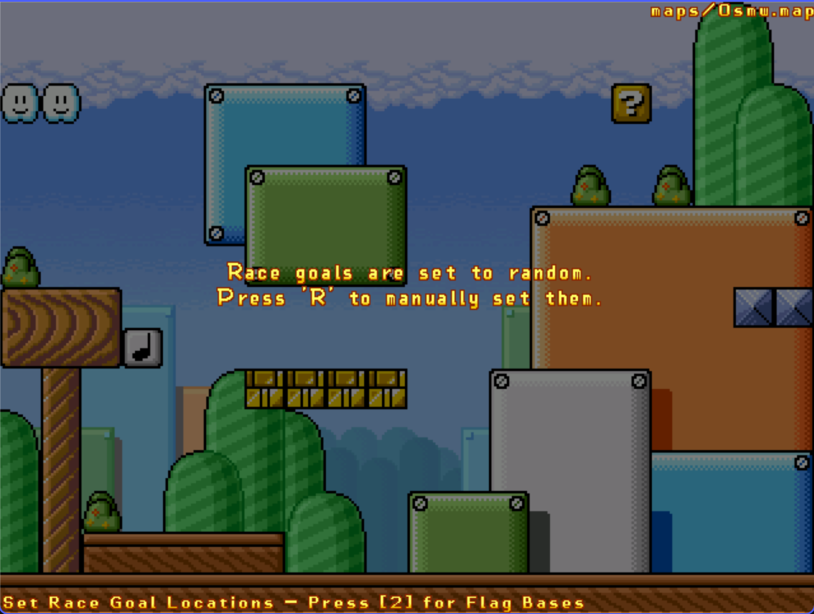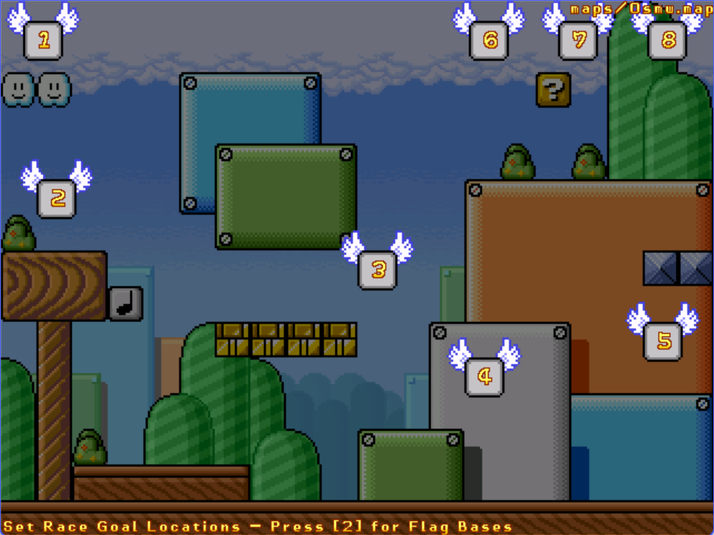

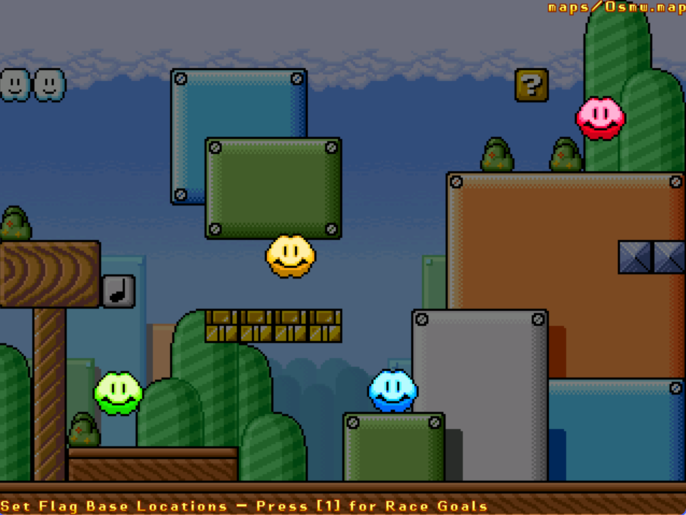
The default setting used for race goals and flag bases is RANDOM, which puts them in random locations every time the game starts.
CONTROLS FOR FLAG BASES/RACE GOALS MODE
R | Toggle mode of location for race goals/flag bases.  - RANDOM is default, putting goals/bases in random locations when spawned.  - MANUAL displays all race goals/flag bases, they can be moved around with the mouse. to set their location. They will stay in place in-game.
Left Mouse Button  (Hold Shift to snap) | Click on race goals/bases and drag to move them around in Manual mode.
Right Mouse Button | Click to remove no-spawn zones.
Numbered keys 1 & 2 | Toggle between Race Goals (1) and Flag Bases (2)

SECTION 11 – Aesthetics
If you wish to go one step further and change the backgrounds, eyecandy, and music category used for the level, look no further:
SUBSECTION 11.1 – Backgrounds
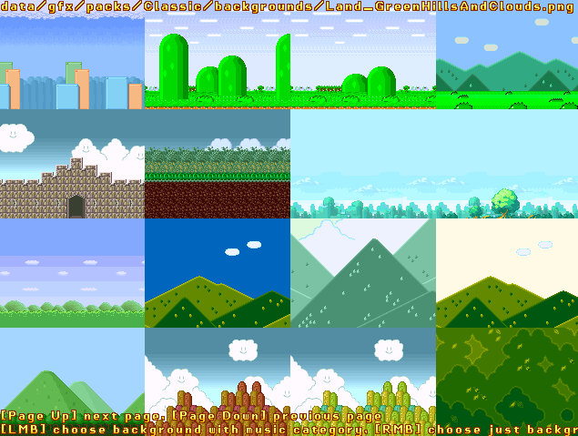
To change the backgrounds, press [B] to bring up the Backgrounds menu. This will bring up a list of backgrounds, which can be scrolled through with PgUp/PgDown.
Backgrounds are loaded from SMWar/gfx/packs/Classic/backgrounds, and contain 640x480 24-bit PNGs of backgrounds. Their names are formatted like this: “(music category)_(name).png” (example: Land_Classic.png).
To choose backgrounds with the corresponding music category on its filename, press Left Mouse Button. To choose a background without changing its music category, press Right Mouse Button.
If you want to choose a different background without going to the backgrounds menu (by scrolling right through backgrounds), press G. Here is an example of a changed background in the map:
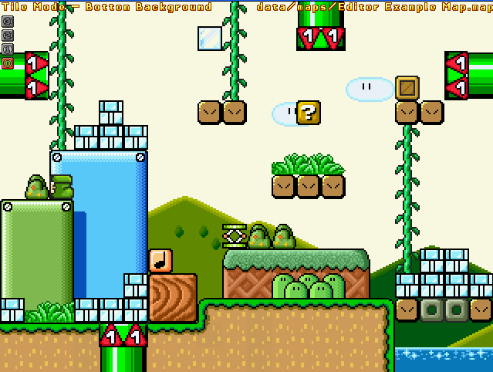
SUBSECTION 11.2 – Music (category)
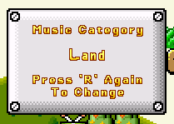
As for music, press R to bring up “Change Music Category”. Press R again to change the music category. There are eleven music categories in the game, which are Land, Underground, Underwater, Castle, Platforms, Ghost, Bonus, Battle, Desert, Clouds, and Snow. Each music category has a different list of music tracks to play, such as ground music for Land, and underground/castle/battle music for Castle.
Note that any music map overrides done in the Overrides.txt file in the music folder may override music categories.
For more information on Music Packs, see the Customization section of the SCW SMWar Game Guide in the documentation folder.
SUBSECTION 11.3 – Eyecandy
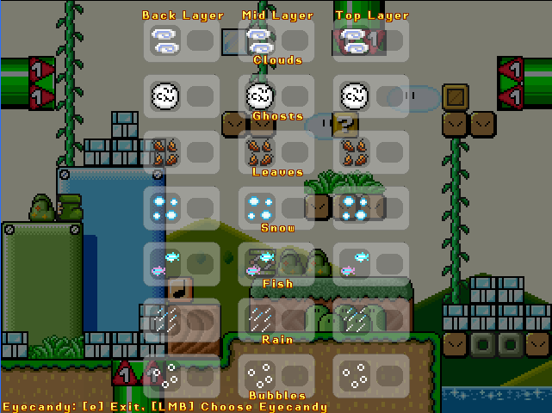
Press E to bring up the Eyecandy menu, which loads aesthetic effects (eyecandy) on to the map in-game. There are eyecandy for clouds, ghosts (Boos & Boo Buddies in SMWar), leaves, snow, fish, rain, and bubbles, and are purely aesthetic.
Rain also sets a special eyecandy that creates splashing effects when players walk around the map.
Each eyecandy has three layers – Back Layer, Mid Layer, and Top Layer. Top Layer has the highest draw priority over almost everything in the map, and Back Layer sets the eyecandy to be drawn at the back. The player can select multiple layer options, but it is recommended to only select one option.
SECTION 12 – Saving & Managing Maps
Finally, you finished making your map! Feel free to press INSERT to take a screenshot and share what you’ve made so far in an image with your friends.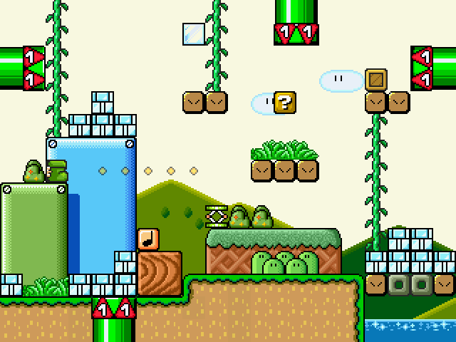
Screenshots are saved in SMWar/maps/screenshots, or in SMWar 2.0 & SCW, it is SMWar/data/maps/screenshots. Note that if there is no directory for such, the screenshot will not save.
And finally, to save your map, press [S]. Press Shift + S to use “Save As”, where you can save a copy of your map under a different name.
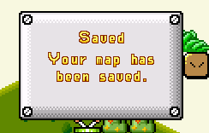
The map is then saved to SMWar/maps, or in SMWar 2.0 & SCW, it is saved to SMWar/data/maps. The map name would be something like “Editor Example Map.map”, with the “.map” extension being the file type that Super Mario War uses to load maps.
If you have noticed, pressing F1 to bring up the controls list also brings up more options for map management.
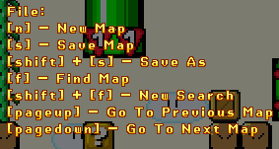
Press F to enable a search function for finding maps, which will look like this:
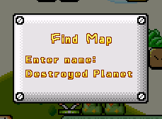
Press Enter to confirm search, and you’ll be directed to the first map with these keywords. In that case, I’ve searched up Destroyed Planet, which brings me to a map also named “Destroyed Planet”:
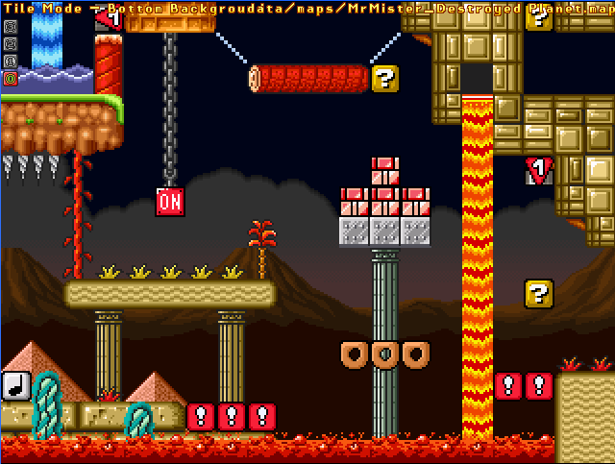
You can also press F again to scroll through other maps that match the queries you have typed. For example, I type in Madness, and press F several times to bring up maps with similar names like:
Press SHIFT + F to bring up the search function again, and type in new keywords.
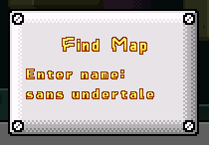
DU DU DU DU
Lastly, pressing Page Up/Page Down allows the player to switch maps. Note that if you’re going to do this, SAVE YOUR MAP first, as if you switch to other maps using this function, any unsaved changes will be lost!
Also, if you feel like bringing in a little bit of destruction, press CTRL+DEL to clear all tiles and data on a map, and start over. This works like the Reset Rocket from the Super Mario Maker series, but NOTE THAT SAVING AN EMPTY MAP OVER ANY COMPLETE MAP WILL RESULT IN ALL DATA FOR THAT MAP BEING LOST! So, use with caution.
SECTION 13 – Playing Your Map (and sharing it!)
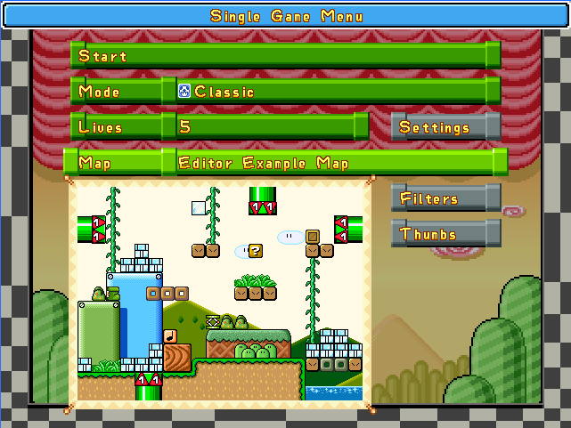
Finally, your map is ready to play! Open up the SMWar executable and go to Single Game Menu, then find the map that you just made and press Start!
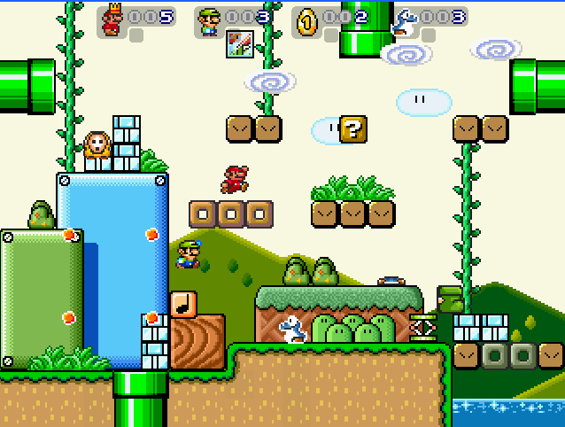
Great job, now you made your custom map! And you’re playing your custom map right now!
SUBSECTION 13.1 – Uploading maps to SMWStuff
By the way, if you have an account on SMWStuff, you can upload your map on the SMWStuff website.
http://smwstuff.net
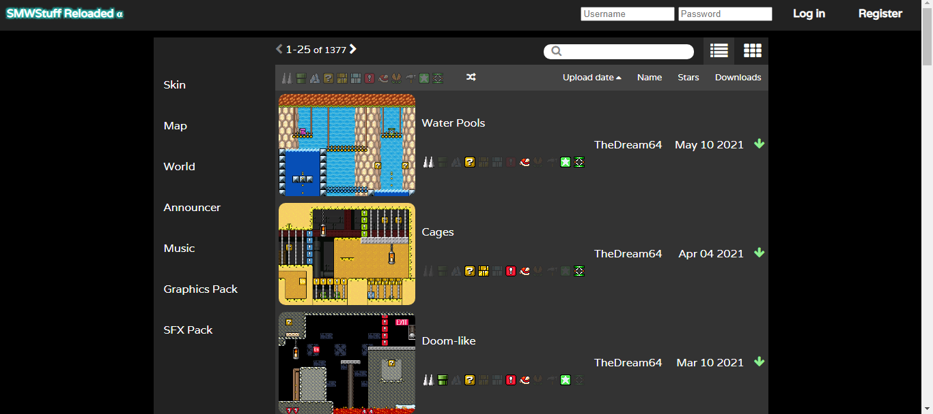
SMWStuff Reloaded is a rebooted version of the original SMWStuff site which has been down for a very long time (especially after SMWar died down in the 2010s). This website is currently being run by mmatyas (previously “fluffypillow”), who is also the developer for SMWar 2.0, also used to run Super Cat Wars. Right now, the site holds skins and maps, and support for worlds, announcers, music, sfx, and graphics will come soon.
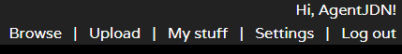
To upload maps, you can log in the website (or register if you do not have an account) and click Upload.
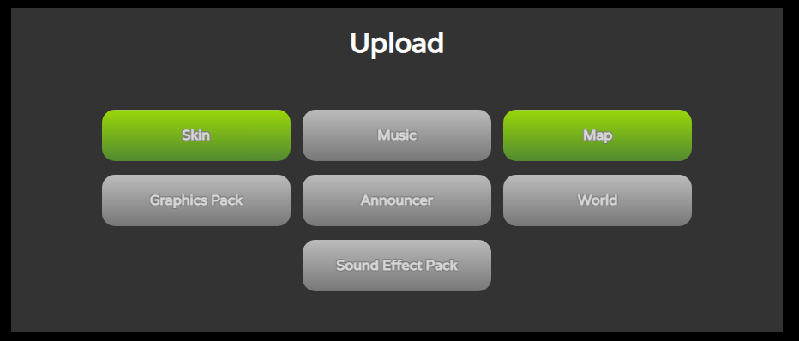
On this page, select Map.
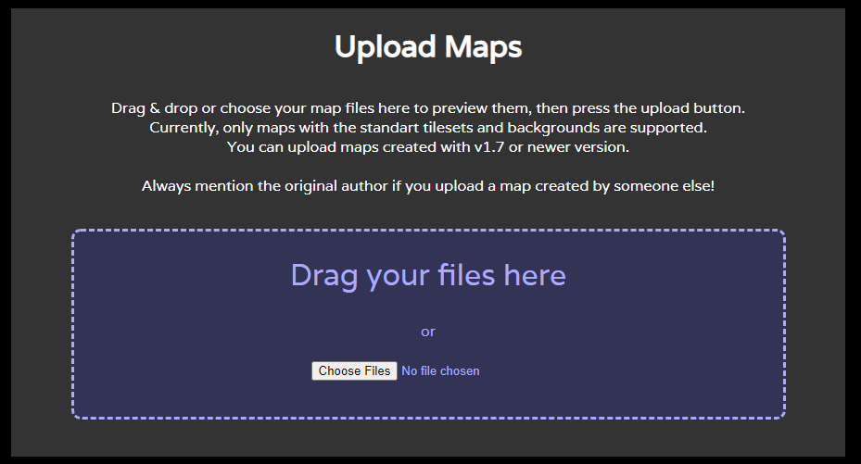
Drag your map file here or select Choose Files and select the map you want to upload.
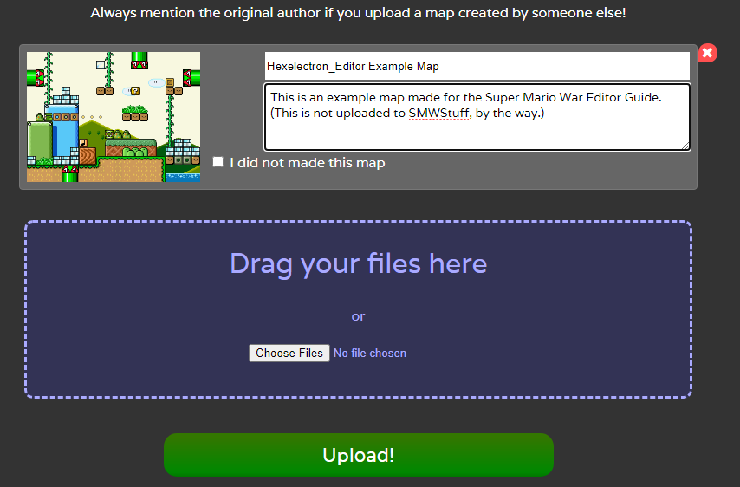
Here you can change the name and description of the map, then select Upload to upload it to SMWStuff. If you want to upload old maps not made by you (for archival purposes), please choose “I did not make this map”. Do not upload maps made by others and claim them as your own, as we do not condone art theft!
After clicking Upload, your map will become available on the site for others to download!
SUBSECTION 13.2 – Multiple uploads on SMWStuff
Due to the way uploading skins and maps is handled on the new SMWStuff website, the player is also capable of uploading multiple skins and maps to the map/skin database. Multiple uploads can be made by dragging and dropping multiple of the same map into the upload page.
While it saves a lot of time, it should be noted that players should never misuse this feature (in ways like spamming the same skin or map, unless if it’s on accident) to avoid bloating the website with unnecessary data.

THANK YOU FOR READING
Thank you for reading the level editor guide! We, from 72dpiarmy, hope you can enjoy creating maps at your own pace.
For game documentation, please see “SCW SMWar Base Game Guide.docx”.
For World Editor documentation, please see “SCW SMWar World Editor Guide.docx”.
For customization documentation, please see “SCW SMWar Customization Guide.docx”.

